|  |  |  |  |  |  |
| --- | --- | --- | --- | --- | --- |
| Date | 24-Nov-22 | | | Tester Name | Mayuri Patel |
| Environment | Penfax - Test | | | Login used |  |
| Operating System | Select OS | Version: | Update: | | |
| Software Used | Select Software | Version: | Update: | | |
| Select Software | Version: | Update: | | |
| Release version | 22.4.1 | | | | |
| Title |  | | | | |
| Test Type | Regression | | | | |
| Test Scenario | Add a contingent(alternate) MEPP Beneficiary | | | | |
|  |  | | | | |
| Expected Results |  | | | | |
| Pass/Fail | Pass | | | JIRA# | N/A |

Describe your steps with screenshots:

Search for any MEPP member that do not have contingent Beneficiary listed yet. (If contingent is already there as beneficiary then new contingent will be added as beneficiary creating multiple contingent as beneficiary on the person profile)

Open that member profile.

Under person profile🡪Beneficiary🡪 Beneficiary Designations

Add beneficiary designation

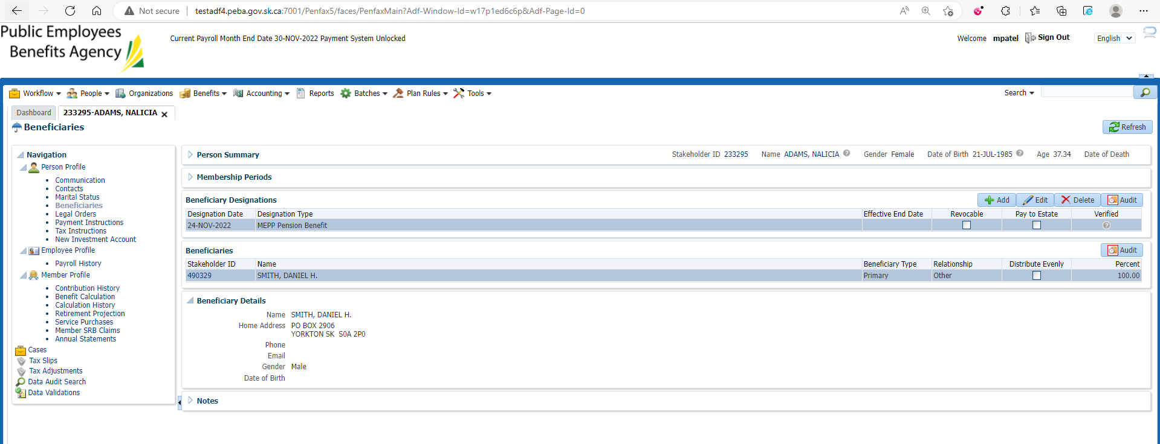

Add beneficiary details or search for beneficiary

Here, new beneficiary details are added and then save the details.

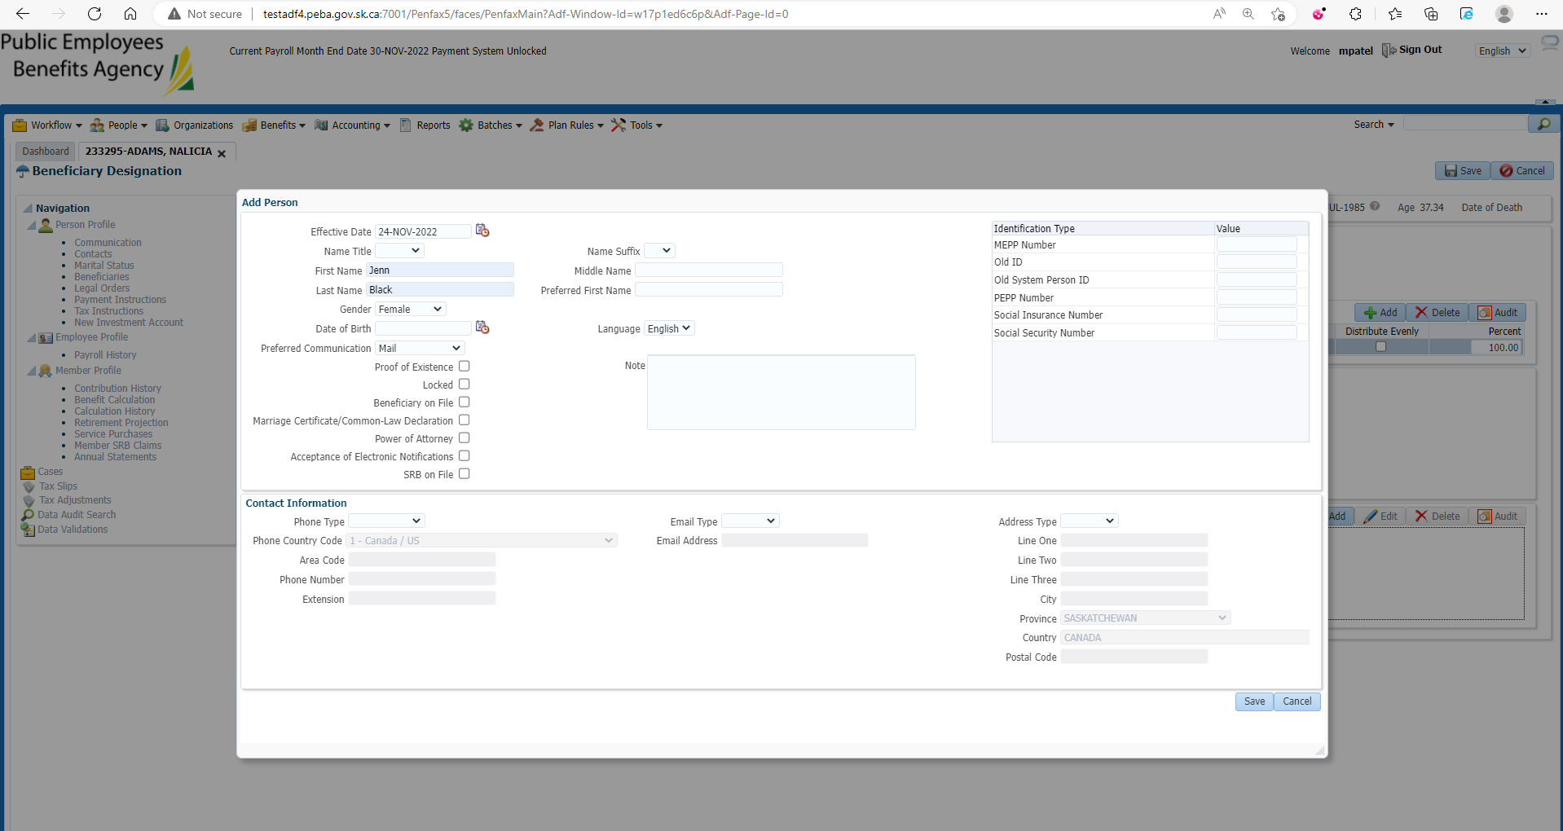

Add Beneficiary Type🡪Contingent, Relationship and percent Amount and then save the details.

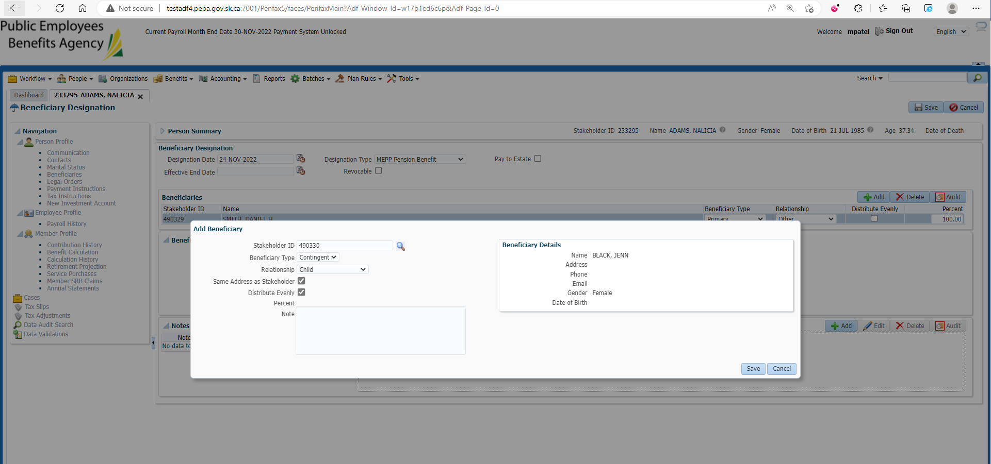

Enter Designation Date, Designation Type and hit save button at the top right corner

New Contingent beneficiary is added

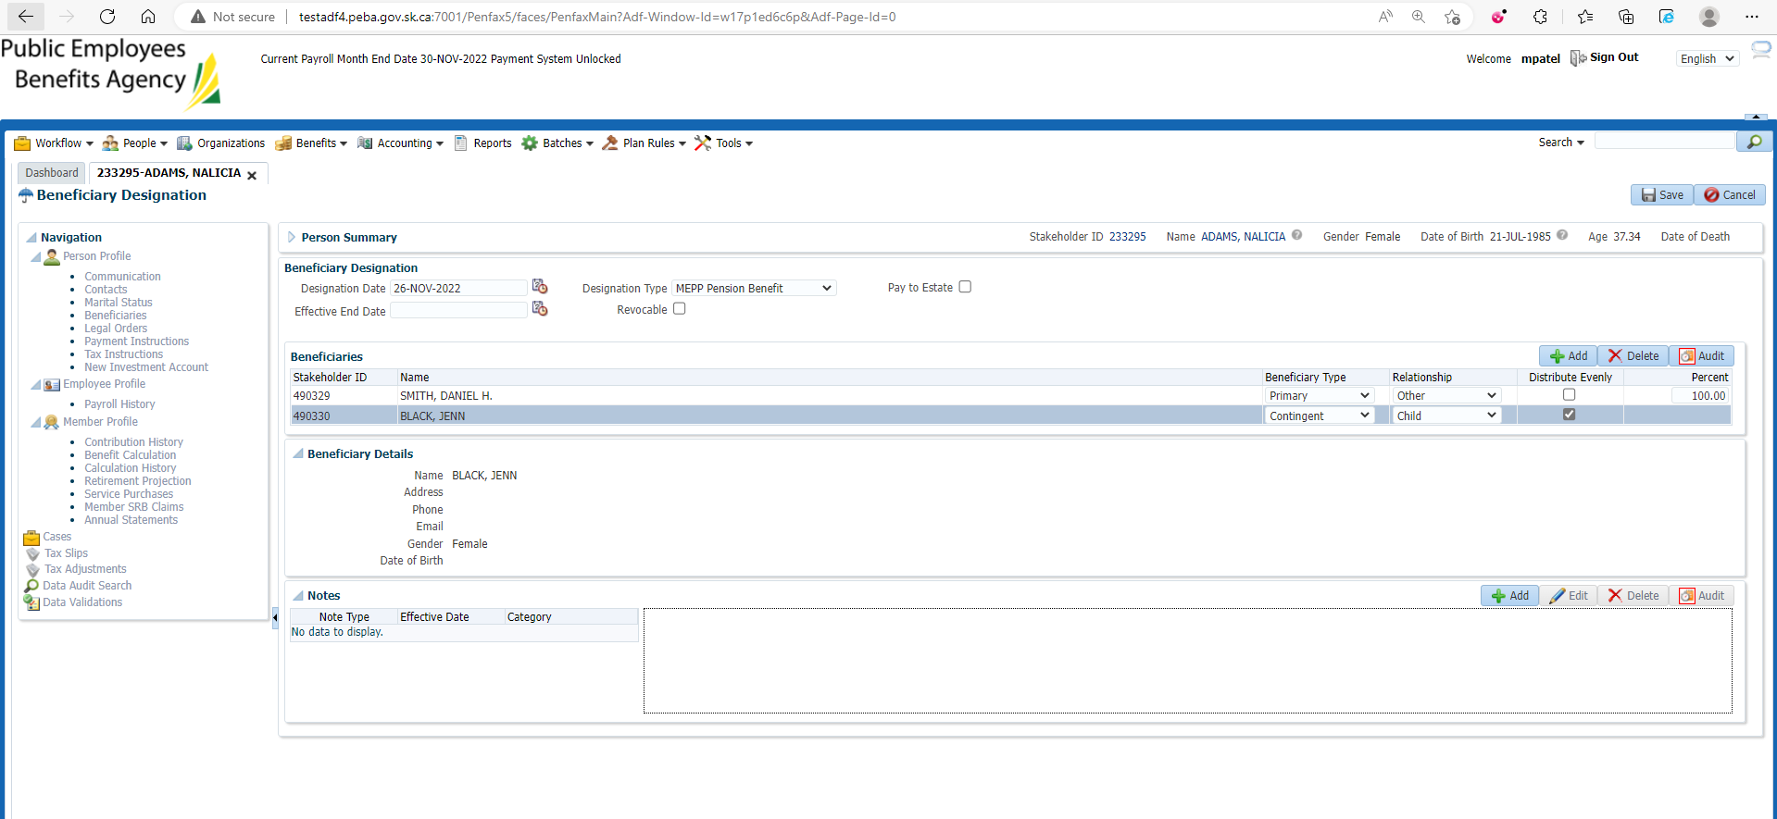

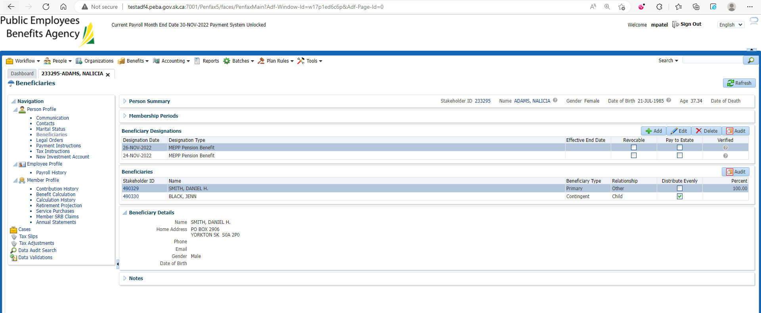

Changes are reflected in Pen web

